CA24 Mobile application collects industry awards
Credit Agricole Bank Polska received a distinction in the „Banking Leader 2018” competition for an innovative form of logging in to CA24 Mobile application.

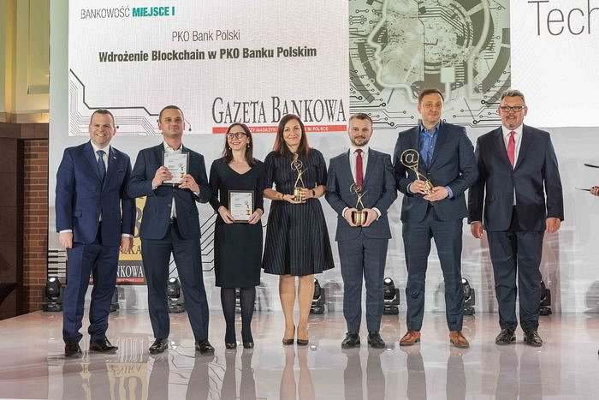
Since November last year, all CA24 Mobile users have been able to use biometric logging. It is an alternative to traditional logging, during which the customer has to enter the application password manually. Now it is enough to place a finger on the built-in reader in the phone and the mechanism compares the fingerprint with the pattern previously registered in the device. If the fingerprints match, the customer will be logged in correctly. The process of logging in with the use of a face image is similar - only a face scan is necessary, consistent with the one previously available in the device (the latter is available only to users of smartphones from the iPhone family).

Technology Competition "Banking Leader 2018" is an undertaking of the editorial staff of "Gazeta Bankowa" whose ambition is to identify the most interesting and innovative solutions that have been implemented (in whole or in part, although this part must constitute a functioning solution at the same time) in 2018. Implementations were selected in three categories: Implementations were selected in three categories: Banking, Insurance and other financial services and Industry 4.0.

It is worth mentioning that the CA24 Mobile application was also recognized as the best banking application in Poland in 2018 in the voting of the "Golden Banker" competition jury.

